# Heatmaps

Choose Heatmaps -> Heatmap General Settings

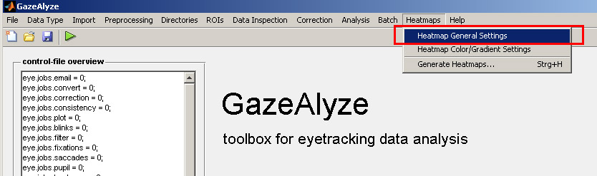

The following window will appear:

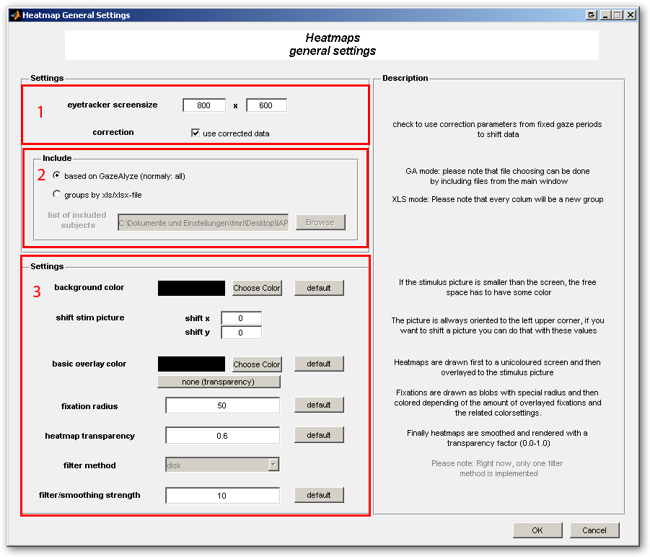

Choose Heatmaps -> Heatmap Color/Gradient Settings

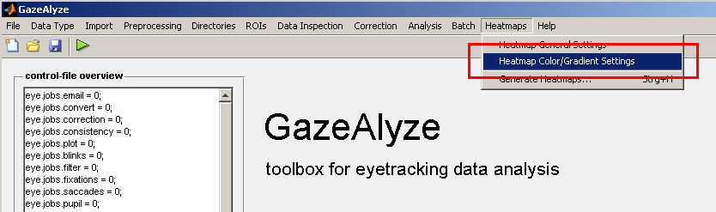

The following window will appear: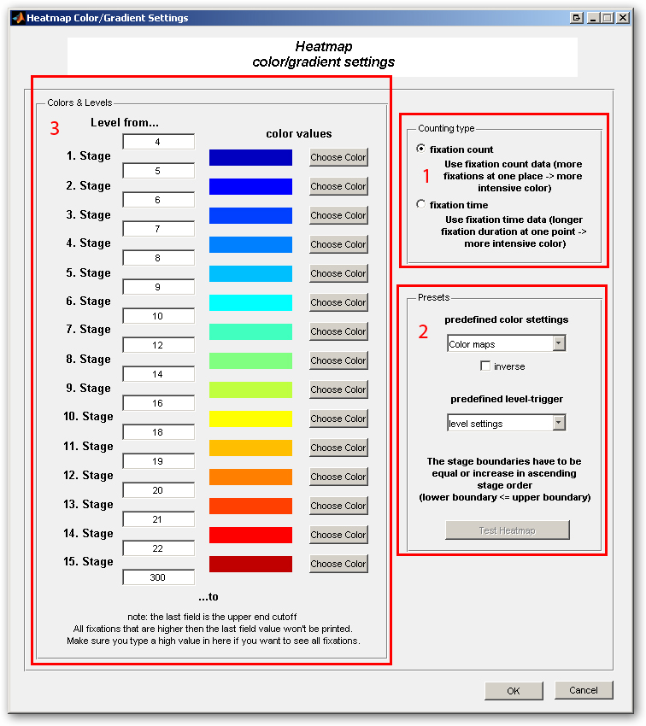

Choose Heatmaps -> Generate Heatmaps

